Strategic Planning and Data Exploration in Logistics
Project Title: Inventory Management and Stockout Reduction in a Retail Supply Chain
Internship: Logistics Data Analyst Intern
Week: Week 1
Tools: Python, Pandas, Matplotlib, Scikit-learn
- Objective:
This task is designed to simulate the planning and strategy phase of a logistics data analysis project.
- Task Requirements:

2.1 Defining a Logistics Scenario
The proposed logistics scenario focuses on inventory management in a retail supply chain. The scenario addresses challenges such as fluctuating demand, insufficient inventory, stockouts, excess inventory and inefficient resource allocation.

2.2 Identifying Key Performance Indicators (KPIs)
Key Performance Indicators (KPIs) are identified to measure and evaluate the performance of inventory and logistics operations. The selected KPIs are Stockout Rate, Inventory Turnover and Order Fulfillment Rate, which represent inventory availability, inventory efficiency and order fulfillment performance.

2.3 Outlining the Strategic Use of Data Science Techniques Using Python
Data science techniques such as regression, clustering and optimization will be strategically applied to analyze demand patterns, identify similar order patterns and support inventory and resource allocation decisions. Python will be used for data analysis, data cleaning, exploratory analysis, visualization, regression and clustering.

- Analytical Approach for Supply Chain Efficiency and Resource Allocation:
The proposed analytical approach uses logistics data to identify demand patterns, understand variations in order volume and support data-driven decision-making. By applying data cleaning, exploratory data analysis, regression and clustering techniques, the project aims to improve the understanding of logistics operations and support more efficient supply chain planning.
The analysis can help identify periods of higher or lower demand, which can support better inventory planning and reduce the risk of stockouts or excess inventory. The insights obtained from the analysis can also help organizations allocate inventory and other logistics resources more effectively according to operational requirements.
- Expected Deliverables:
The primary deliverable for this task is a comprehensive DOC file containing the strategic planning report. The report will document the proposed logistics scenario, relevant KPIs, data research, analytical approach, strategic roadmap, Python code illustrations and expected outcomes.

- Research, Objectives and Analysis Roadmap:
5.1 Background Research
Logistics and inventory management play an important role in maintaining an efficient supply chain. Organizations need to maintain sufficient inventory to meet customer demand while avoiding excessive inventory and unnecessary resource utilization.
Data analytics can help organizations examine historical order information, identify demand patterns, understand variations in order volume and support better inventory planning. Data science techniques can further support this process by providing predictive and analytical insights for logistics decision-making.

5.2 Project Objectives
The objectives of the proposed project are:
- To analyze historical logistics order data and identify demand patterns.
- To evaluate relevant KPIs for inventory and logistics performance.
- To explore regression techniques for estimating total order demand.
- To apply clustering techniques to identify similar order patterns.
- To examine how optimization can support inventory and resource allocation.
- To develop a Python-based analytical approach for logistics decision-making.

5.3 Roadmap for the Analysis
The proposed analysis follows an end-to-end process:
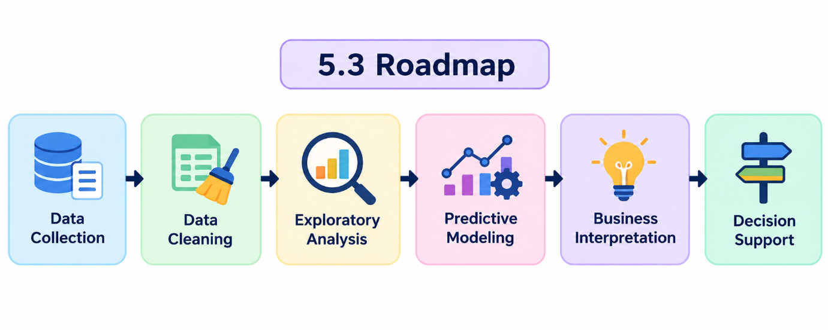

5.3 Roadmap: The analysis follows a structured process from Data Collection to Decision Support, transforming logistics data into actionable business insights.
- Python Code Illustration:
Python code will be used to demonstrate the proposed logistics data analysis approach. The scripts will cover data loading, data inspection, data cleaning, exploratory data analysis, visualization, regression and clustering. The code will illustrate how the logistics data can be processed and analyzed to support the proposed inventory management scenario.

6.1 Data Loading and Inspection
import pandas as pd
df = pd.read_csv( "Daily_Demand_Forecasting_Orders.csv",
sep=";"
)
print(df.shape)
print(df.head())
df.info()

6.2 Data Cleaning Checks
print(df.isnull().sum())
print(df.duplicated().sum())
print(df.dtypes)
6.3 Exploratory Data Analysis
import matplotlib.pyplot as plt
df ["Target (Total orders)"].plot(
kind="hist",
bins=10
)

plt.title("Distribution of Total Orders")
plt.xlabel("Total Orders")
plt.ylabel("Frequency")
plt.show()

6.4 Regression
from sklearn.model_selection import train_test_split
from sklearn.linear_model import LinearRegression

X = df.drop("Target (Total orders)", axis=1)
y = df["Target (Total orders)"]
X_train, X_test, y_train, y_test = train_test_split( X, y,
test_size=0.2,
random_state=42
)
model = LinearRegression()
model.fit(X_train, y_train)
y_pred = model.predict(X_test)
6.5 Clustering
from sklearn.preprocessing import StandardScaler
from sklearn.cluster import KMeans

features = [
"Non-urgent order",
"Urgent order",
"Order type A",
"Order type B",
"Order type C"
]

X_cluster = df[features]
scaler = StandardScaler()
X_scaled = scaler.fit_transform(X_cluster)

kmeans = KMeans(
n_clusters=3,
random_state=42,
n_init=10
)
df["Cluster"] = kmeans.fit_predict(X_scaled)

- Project Definition:
7.1 Logistics Scenario
The proposed project focuses on inventory management in a retail supply chain. A retail company receives different types of orders and needs to maintain sufficient inventory to meet customer demand while avoiding excessive inventory.
The company experiences fluctuations in order demand. During periods of high demand, insufficient inventory may result in stockouts and delayed order fulfillment. During periods of low demand, excess inventory may increase storage costs and lead to inefficient use of resources.
The company therefore requires a data-driven approach to understand historical order patterns and support better inventory planning and resource allocation.
The proposed project will use publicly available logistics order data and Python-based analytical techniques to explore demand patterns and demonstrate how data analysis can support inventory management and supply chain decision-making.

- Three Relevant KPIs:
8.1 Stockout Rate
Stockout Rate measures the percentage of demand or order events that cannot be fulfilled because the required inventory is unavailable.
Formula:
Stockout Rate = (Stockout Events / Total Order Events) × 100

For example, if 20 out of 200 order events experience a stockout:
Stockout Rate = (20 / 200) × 100 = 10%
Relevance: This KPI helps the company monitor product availability and identify the risk of insufficient inventory.

8.2 Inventory Turnover
Inventory Turnover measures how efficiently inventory is used or sold during a specific period.
Formula: Inventory Turnover = Cost of Goods Sold / Average Inventory
A lower turnover may indicate slow-moving inventory, while an unusually high turnover may indicate that inventory levels are too low.
Relevance: This KPI helps the company evaluate inventory efficiency and make better inventory planning decisions.

8.3 Order Fulfillment Rate
Order Fulfillment Rate measures the percentage of total orders that are successfully fulfilled.
Formula: Order Fulfillment Rate = (Fulfilled Orders / Total Orders) × 100
For example, if 950 out of 1,000 orders are fulfilled:
Order Fulfillment Rate = (950 / 1000) × 100 = 95%
Relevance: This KPI helps evaluate the company's ability to satisfy customer demand and maintain reliable order fulfillment.

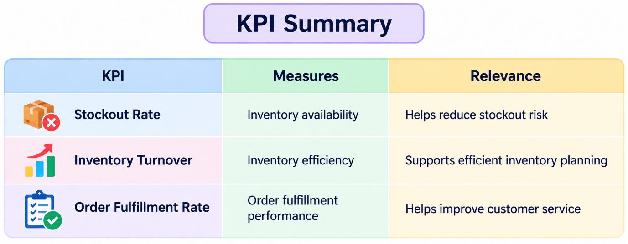

The selected KPIs provide a clear framework for evaluating inventory and logistics performance. Stockout Rate measures inventory availability, Inventory Turnover evaluates inventory efficiency and Order Fulfillment Rate measures the effectiveness of fulfilling customer orders. Together, these KPIs can support better inventory planning, reduce stockout risk, improve resource utilization and enhance customer service.

- Literature and Data Research:
9.1 Literature Research
Supply chain analytics uses data analysis, forecasting, optimization and visualization to improve supply chain planning and decision-making. In inventory management, demand forecasting can help organizations maintain appropriate stock levels and reduce the risks of both stockouts and excess inventory.
Research on inventory management also shows that demand forecasting and inventory optimization can be combined to determine appropriate inventory levels while considering operational constraints.
These findings support the proposed scenario because the project focuses on understanding order demand and using analytical techniques to improve inventory planning and resource allocation.

9.2 Public Data Research
For the project analysis, the Daily Demand Forecasting Orders dataset from the UCI Machine Learning Repository was selected. The dataset was collected over 60 days from a real Brazilian logistics company and contains 12 predictive attributes and a target variable representing total daily orders. The dataset has no missing values and is associated with the regression task.
The dataset is relevant to the proposed scenario because it provides real logistics order information that can be used to explore demand patterns, demonstrate regression and other analytical techniques.
Data Source: UCI Machine Learning Repository – Daily Demand Forecasting Orders

9.3 Relevance to the Proposed Scenario
The literature supports the use of analytics for demand forecasting, inventory planning and resource allocation, while the selected public dataset provides real logistics order data for analysis. Together, these resources provide a foundation for the proposed inventory management and logistics analytics project.

9.4 References
- IBM – Supply Chain Analytics
- IBM – Demand Forecasting
- IBM Research – Omnichannel Inventory Replenishment Optimization
- UCI Machine Learning Repository – Daily Demand Forecasting Orders

10) Application of Data Science Concepts:
10.1 Regression
Regression is a predictive data science technique used to estimate a numerical value based on historical data.
In this project, regression can be applied to estimate total order demand using historical logistics order information. The available order-related variables can be used as input features, while Target (Total orders) can be used as the target variable.
The predicted demand can support better demand planning and inventory allocation by helping the organization understand expected order volume.

10.2 Clustering
Clustering is an unsupervised data science technique used to group similar observations based on their characteristics.
In this project, clustering can be applied to group order records based on variables such as Non-urgent orders, Urgent orders, and Order Types A, B and C. This can help identify different order activity patterns.
These groups can support business teams in understanding different demand patterns and planning resources according to operational requirements.

10.3 Optimization
Optimization is a data science technique used to identify the best possible decision while considering business constraints.
In this project, optimization can be used in a future implementation to determine how available inventory and other logistics resources should be allocated efficiently across different requirements. The optimization process can consider factors such as predicted demand, inventory availability, warehouse capacity and transportation constraints.
This can help reduce the risk of stockouts and excess inventory while improving resource utilization.

10.4 Role of Python
Python will be used as the primary programming language for implementing the proposed analytical approach. Libraries such as Pandas can be used for data processing, Matplotlib for visualization and Scikit-learn for regression and clustering.
11) Strategic Roadmap:
The proposed analysis will follow an end-to-end process to transform logistics data into useful business insights and support data-driven decision-making.

11.1 Data Collection
Collect relevant logistics order data from publicly available sources. The selected UCI Daily Demand Forecasting Orders dataset will be used for the analysis.

11.2 Data Cleaning
Inspect the collected data for missing values, duplicate records, incorrect data types and invalid values. Appropriate cleaning techniques will be applied based on the characteristics and business meaning of the data.

11.3 Exploratory Data Analysis (EDA)
Explore the cleaned data to understand demand distributions, variations, trends, relationships and unusual observations. Python visualization libraries such as Matplotlib will be used to create charts and identify meaningful patterns.

11.4 Predictive Modeling
Apply regression using Python to estimate total order demand based on relevant historical order variables. The model will be trained and evaluated to understand its predictive performance.

11.5 Pattern Identification
Apply clustering to identify groups of similar order activity patterns. These patterns can provide additional insights for logistics planning.

11.6 Business Interpretation and Decision Support
Translate the analytical findings into business insights that can support inventory planning, resource allocation, and supply chain decision-making. Optimization can be considered as a future stage when detailed inventory and operational constraints are available.

11.7 Process Flow
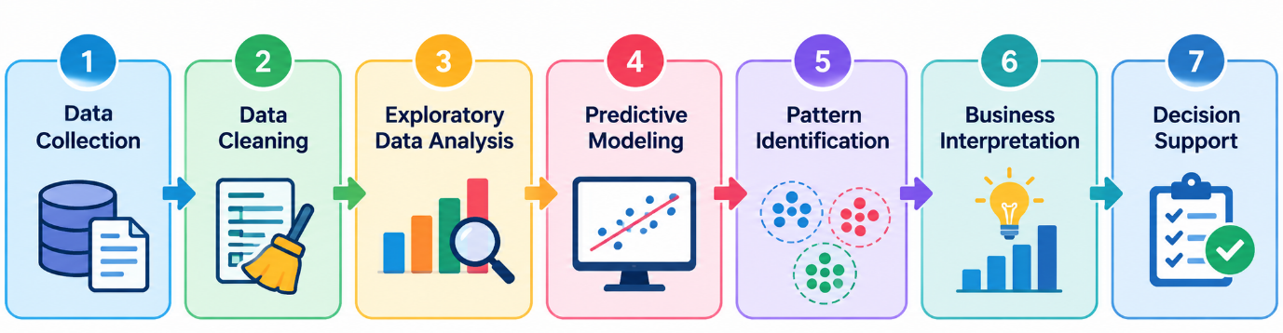
12) Code Illustration:
The following Python snippets illustrate the proposed logistics data analysis approach using the selected dataset.
12.1 Data Loading and Inspection
Purpose: Loads the logistics dataset into a Pandas DataFrame and performs an initial inspection of its structure and contents.
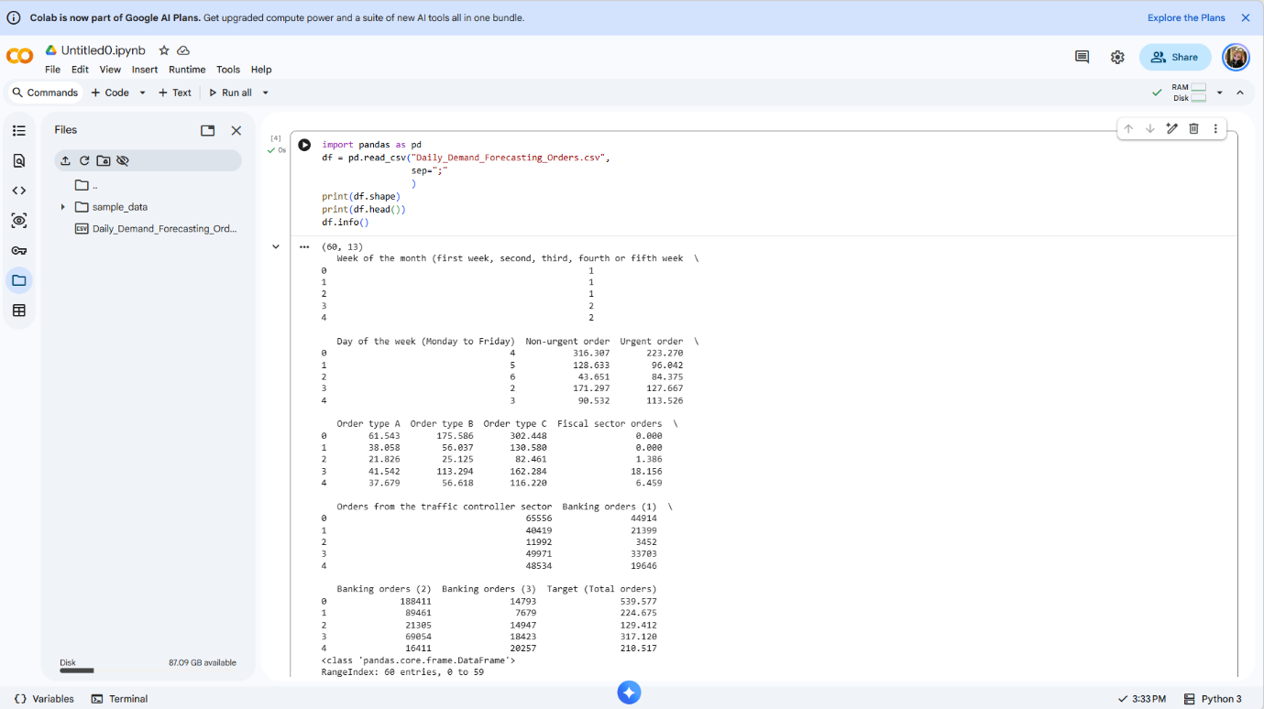
Figure 1: Initial dataset inspection using Python
12.2 Data Cleaning Checks
Purpose: Checks for missing values, duplicate records, and data types before performing further analysis.

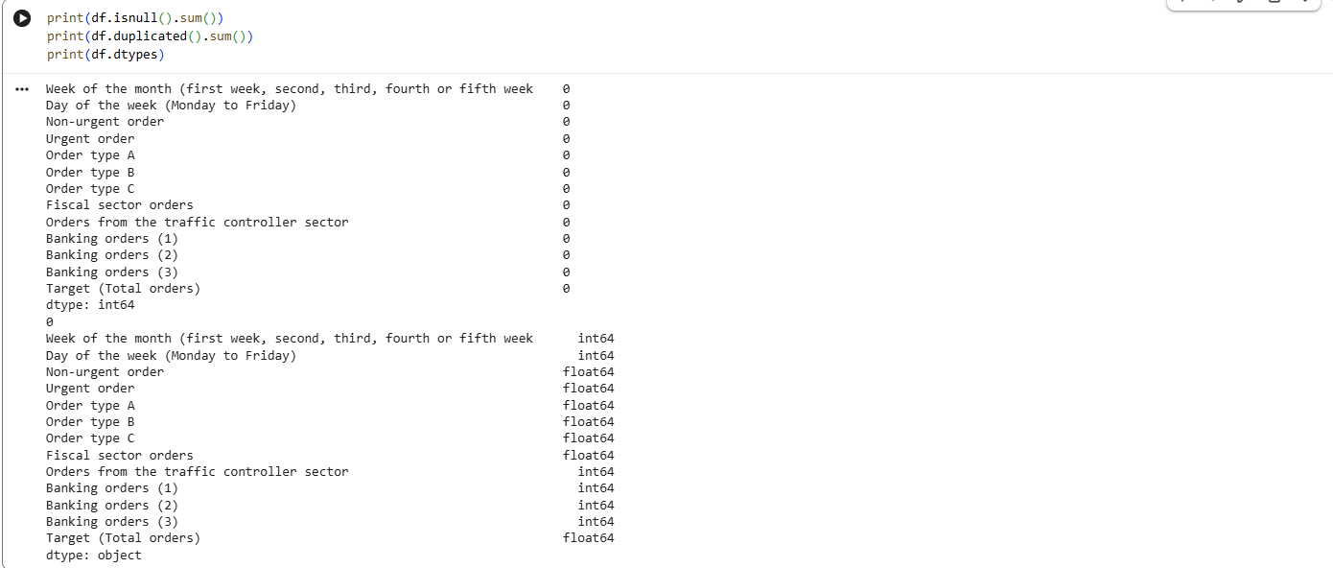

Figure 2: Python-based data cleaning checks

12.3 Exploratory Data Analysis
Purpose: Visualizes the distribution of total orders to understand demand patterns and variations.
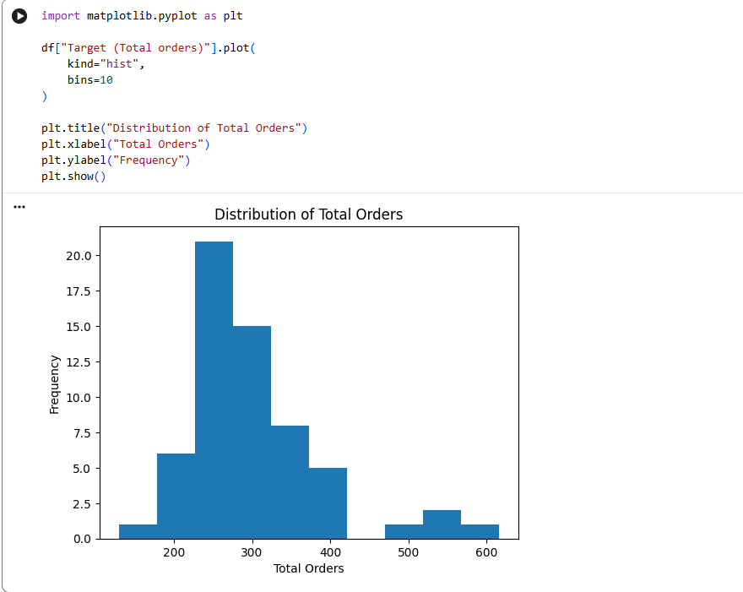
Figure 3: Distribution of Total Orders
12.4 Regression
Purpose: Demonstrates how regression can be used to estimate total order demand from the available input variables.
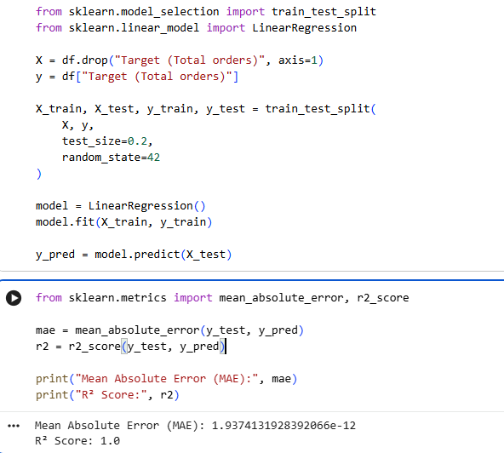
Figure 4: Linear Regression model evaluation using Python

Result: The Linear Regression model produced an MAE of approximately 0 and an R² score of 1.0 on the test data. The results indicate an extremely close fit between the predicted and actual target values. However, because the input variables are directly related to the total-order target, the result should be interpreted as a demonstration of the regression approach rather than as evidence of production-ready future demand forecasting.
12.5 Clustering
Purpose: Groups similar order records based on their order characteristics, helping identify different order activity patterns.
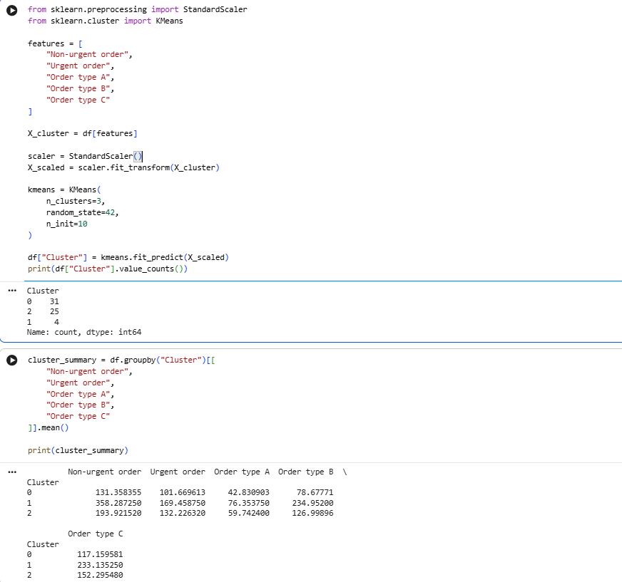
Figure 5: K-Means clustering and cluster analysis using Python
Result: K-Means clustering grouped the 60 logistics records into three distinct order-activity patterns. Cluster 0 represented lower order activity, Cluster 2 represented medium order activity, and Cluster 1 represented higher order activity based on the average values of the selected order variables.
12.6 Code Illustration Summary
These Python snippets demonstrate the proposed analytical workflow, including data loading, data quality checks, exploratory analysis, regression and clustering. The code provides a practical foundation for analyzing logistics order data and generating insights for inventory planning and resource allocation.

13) Conclusion:
The proposed logistics analytics approach provides a structured framework for analyzing order data and supporting inventory management and supply chain planning. The analysis uses Python for data loading, data cleaning, exploratory analysis, regression and clustering to identify demand patterns and different order-activity groups.
The expected outcomes include better demand visibility, improved inventory planning, more effective resource allocation and reduced risk of stockouts or excess inventory. The regression analysis can support demand estimation, while clustering can help identify different order-activity patterns. Optimization can be considered as a future stage when detailed inventory, warehouse and operational constraint data are available.
These analytical results can support logistics decision-making by helping organizations understand changes in order demand and allocate resources more effectively. Instead of relying only on assumptions, decision-makers can use data-driven insights to improve planning, prioritize operational requirements and make more informed supply chain decisions.
Overall, the proposed approach demonstrates how data science and Python-based analytics can transform logistics data into actionable insights that support more efficient and data-driven decision-making.

